***Assignment Name****:* ***Lab3:******(Operators and Selection)***

***Due date:******9/28/2022, by 11:00 am.***

***Grade for assignment: 30*** *points*

***Purpose:*** *Obtain experience in using operators and selection statements when writing programs. Assignment accomplishes course learning objective “using basic control structures”. Assignment also provides preparation for COSC236 course, and enhances skills needed in Information Technology (IT) and Computer Science industries.*

***Skills:*** *Purpose of assignment is to help you practice the following skills.*

*-Recognize when to use selection statements.*

*-Ability to effectively use operators.*

***Knowledge:*** *Become familiar with decision control structures when writing computer programs.*

***\*\*\*\*\*\*\*\*\*\*\*\*\*\*\*\*\*\*\*\*\*\*\*\*\*\*\*\*\*\*\*\*\*\*\*\*\*\*\*\*\*\*\*\*\*\*\*\*\*\*\*\*\*\*\*\*\*\*\*\*\*\*\*\*\*\*\*\*\*\*\*\*\*\*\*\****

***Place your Name(s) below:***

***Pairs work:*** *Please work in pairs.* ***One student in team should submit work****. Put* ***your first and last name on the assignment*** *and* ***your partner’s first and last name on the*** *assignment*

***Note(s):***

1. *All programs should be completed within the Visual Studio Code environment. There are guides in blackboard to start you off with Visual Studio Code.*

***Partner 1: Name*** *Blessing Abumere*

***role (did the typing or read and review) _____________________________***

***Partner 2: Name ______________________________________________***

***role (did the typing or read and review)______________________________***

***Please note if one partner did not work on all problems.***

***Submission instructions:*** *All submissions will be done using blackboard.* ***Answers are to be submitted in a Microsoft word document.***

***Task****:*

***Examples:*** *Refer to your notes from class, the Operators PowerPoint and video and the Selection PowerPoint and any available videos (all located in Blackboard).*

***Part1 (30 Points):***

1. *Type in the following program. Add a comment at the top to include your name and the date.*

//this program demonstrates the use of various operators

#include <iostream>

using namespace std;

int main()

{

      int num1;

int num2;

      int sum;

int diff;

int prod;

      float quot;

      cout << "Enter two integer values" << endl;

      cin >> num1 >> num2;

      sum = num1 + num2;

cout << num1 << " + " << num2 << " is " << sum << endl;

      diff = num1 - num2;

cout << num1 << " - " << num2 << " is " << diff << endl;

      prod = num1 * num2;

cout << num1 << " * " << num2 << " is " << prod << endl;

quot = (float) num1 / num2;

      cout << num1 << " / " << num2 << " is " << quot << endl;

  return 0;

}

1. *Compile and Run with different values. (use: positive numbers, negative numbers, zero)*
2. *Add code to compute the modulus. Hint: you will also have to declare a new variable.*
3. *Answer the following questions:*
4. *What happens when num2 is 0? Why?* 
   1. The quotient (/) will always show “inf”
   2. The product (*) will always show 0
   3. The modulus (%) line does not run and does not allow the code beneath it to run.
5. *What does this tell you about using division or modulus in your programs?*
   1. This tell me that when using division or modulus in my programs I should always create a conditional statement for if a number is dividing 0 .
6. *Add the following lines to correct the divide by zero, problem. Compile and run with different values to ensure it works correctly. (Note: DO NOT change the if statement.* **Enter your code into the else statement**.)

     if (num2 == 0)

{

cout << “cannot divide by zero!” << endl;

}

else

{

quot = (float) num1 / num2;

cout << num1 << " / " << num2 << " is " << quot << endl;

mod = num1 % num2;

cout << num1 << " % " << num2 << " is " << mod << endl;

}

1. ***SUBMIT your corrected code, and sample of output (Below):***
2. /*
3. Blessing Abumere
4. 9/21/2022
5. GEN COMPUTER SCI (COSC175006)-1224
6. */
7. #include <iostream>
8. using namespace std;
9. int main(){
10. int num1;
11. int num2;
12. int sum;
13. int diff;
14. int prod;
15. int mod;
16. float quot;
18. cout << "Enter two integer values" << endl;
19. cin >> num1 >> num2;
20. sum = num1 + num2;
21. cout << endl <<  num1 << " + " << num2 << " is " << sum << endl;
22. diff = num1 - num2;
23. cout << num1 << " - " << num2 << " is " << diff << endl;
24. prod = num1 * num2;
25. cout << num1 << " * " << num2 << " is " << prod << endl;
26. if (num2 == 0)
27. {
28. cout << "cannot divide by zero!" << endl;
29. }
30. else
31. {
32. mod = num1 % num2;
33. cout << num1 << " % " << num2 << " is " << mod << endl;
34. quot = (float) num1 / num2;
35. cout << num1 << " / " << num2 << " is " << quot << endl;
36. }
37. return 0;
38. }

***Output Below***

***\*\*\*\*\*\*\*\*\*\*\*\*\*\*\*\*\*\*\*\*\*\*\*\*\*\*\*\*\*\*\*\*\*\*\*\*\*\*\*\*\*\*\*\*\*\*\*\*\*\*\*\*\*\*\*\*\*\*\*\*\*\*\*\*\*\*\*\*\*\*\*\*\*\*\*\*\****

***Criteria for Success****:*

***a****) Be sure to submit your code and output above for each question;* ***Submission of Code and output is required****. (Note: use screen shots or copy and paste).*

*For example if the assignment was to write a program that displays “Hello World”*

*Your* ***code*** *would be as follows:*

*//Lab1 answer COSC175002*

*#include <iostream>*

*using namespace std;*

*int main()*

*{*

*cout << "Hello, world" << endl;*

*system("pause");*

*} // end of main*

*Your* ***output*** *would be as follows:*

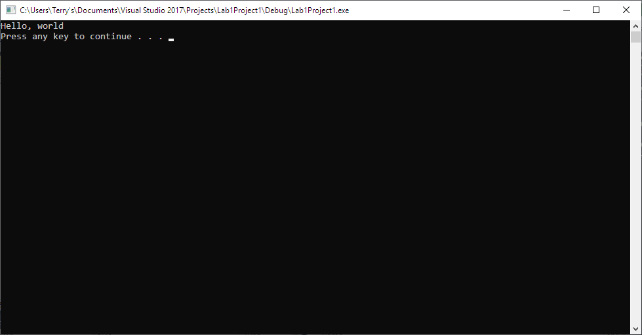

*Note: To avoid additional point deductions; remember to submit both code and output.*

***b) Late policy:*** *Late submissions will receive a zero grade. Get help during the week so that you can submit on time.*